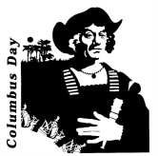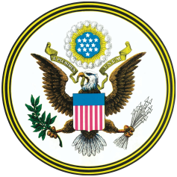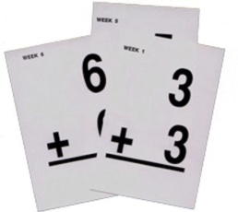

**School News**

September 17-21: Book Fair

September 18: Walk to School Day

PTO Meeting at 6

Board Meeting at 7

September 19: Family Reading Night at 6-8

September 21: Picture Retake Day

September 28: PTO Fundraiser Ends

October 5: No School

October 8: No School, Columbus Day

**Math**

**Chapter 2: Addition Test**

**on Thursday, September 20**

Starting Chapter 3: Subtration on Friday, September 21

**Science/ Social Studies**

September 17 is Constitution Day! We will be learning about the Constitution.

We will start science this week!

We are learning about why plants grow flowers and how bees help with pollination.

**Language Arts**

Our next story is a biography called *All Aboard! Elijah McCoy’s Steam Engine*.

The skills we will be covering are…

* Ask and Answer Questions
* Cause and Effect
* Metaphors
* Predicates
* Plurals (-s and –es)

**Grammar, Vocabulary, and Spelling Tests: September 24**

**\*** This week’s spelling list is on the back of this newsletter! *

Teacher Contact Information

|  |  |
| --- | --- |
| **Teacher** | **Ext.** |
| agriffith@pwh105.org | 119 |
| lmehrtens@pwh105.org | 118 |
| cdipasquale@pwh105.org | 116 |

September 17 - 24

#ThirdGradeNews